**Assignment -1**

**Arduino Uno Programming**

|  |  |
| --- | --- |
| Assignment Date | 15 September 2022 |
| Student Name | Sangeetha G |
| Student Roll Number | 912419104025 |
| Maximum Marks | 2 Marks |

To create circuit with Piezo alarm ,PIR sensor ,Temperature sensor with the following functionalities:

**Question-1:**

Alarm should sound in one manner if temperature is above 60 degree C:-

void setup()

{

Serial.begin(9600);

pinMode(13,OUTPUT);

}

void loop()

{

int data=analogRead(A0);

double n=data/1024;

double volt=n*6;

double off=volt-0.6;

double temperature=off*100;

Serial.print("Temperature data: ");

Serial.println(temperature);

tone(13,100);

delay(1000);

tone(13,200);

delay(1000);

}

SCREENSHOT:

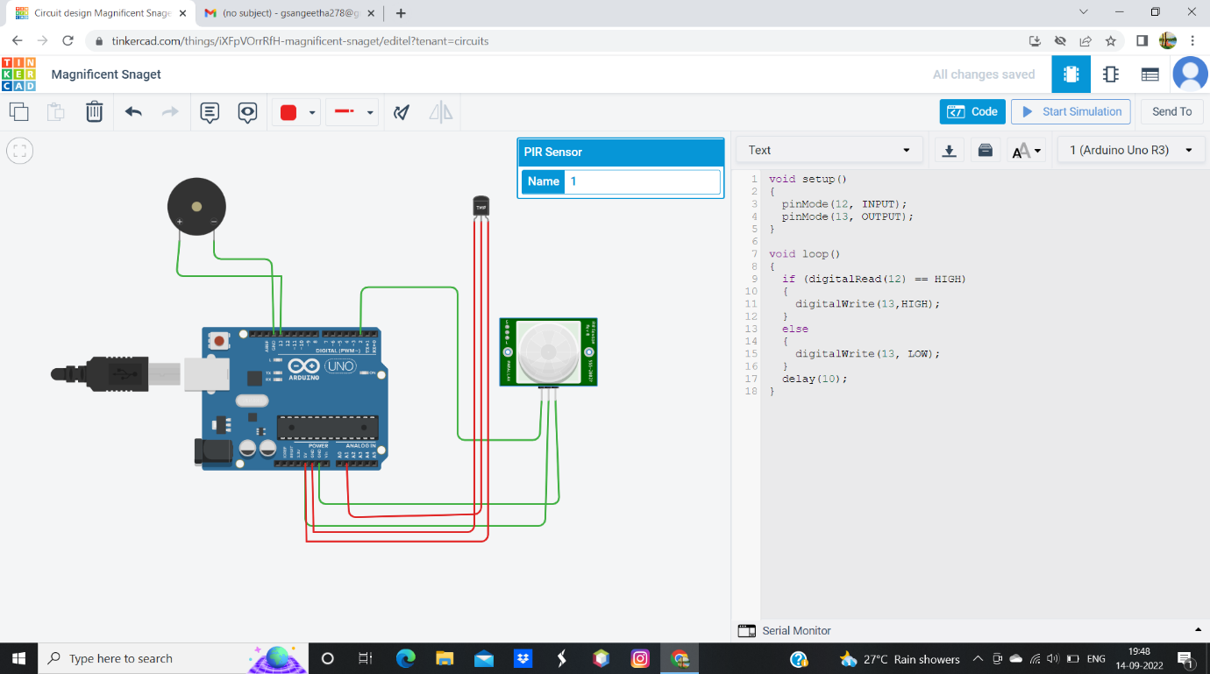

**Question-2**:

Alarm should sound with another frequency if motion is detected in PIR sensor:-

void setup()

{

pinMode(12,INPUT);

pinMode(13,OUTPUT);

}

void loop()

{

if(digitalRead(12) == HIGH)

{

digitalWrite(13,HIGH);

}

else

{

digitalWrite(13,LOW);

}

delay(10);

}

SCREENSHOT:

